**Frame**: Entire packet captured by Wireshark is 4690 (550 Bytes).

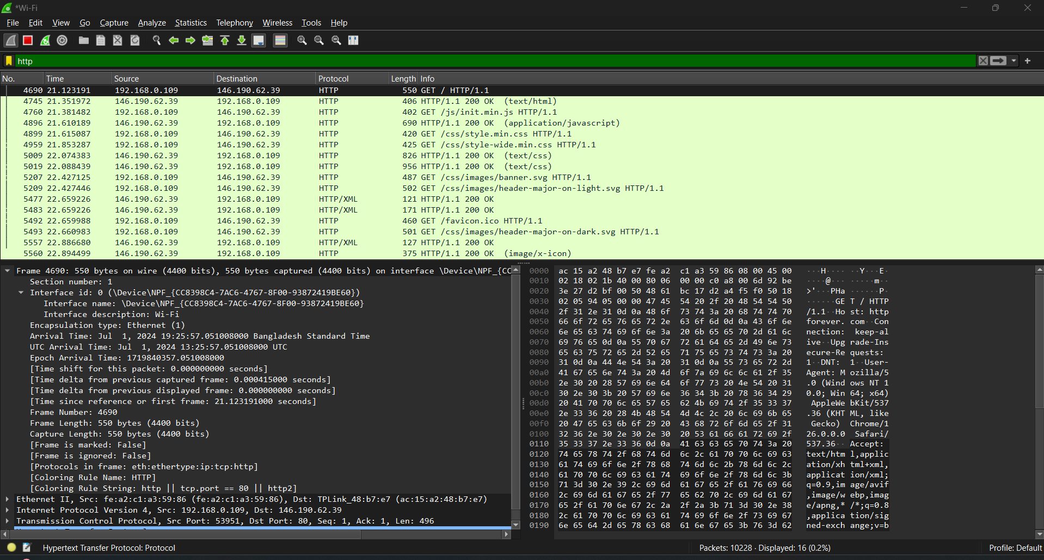

**Data Link Layer protocol**: It is responsible for framing the packet for transmission over the physical network. Here it is Ethernet II.

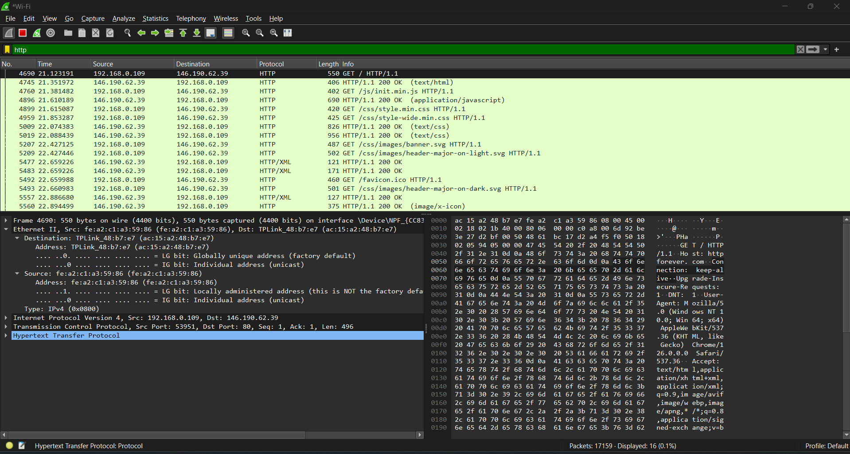

**Network Layer Protocol:** Responsible for routing the packet across different networks. Here it is IPV4.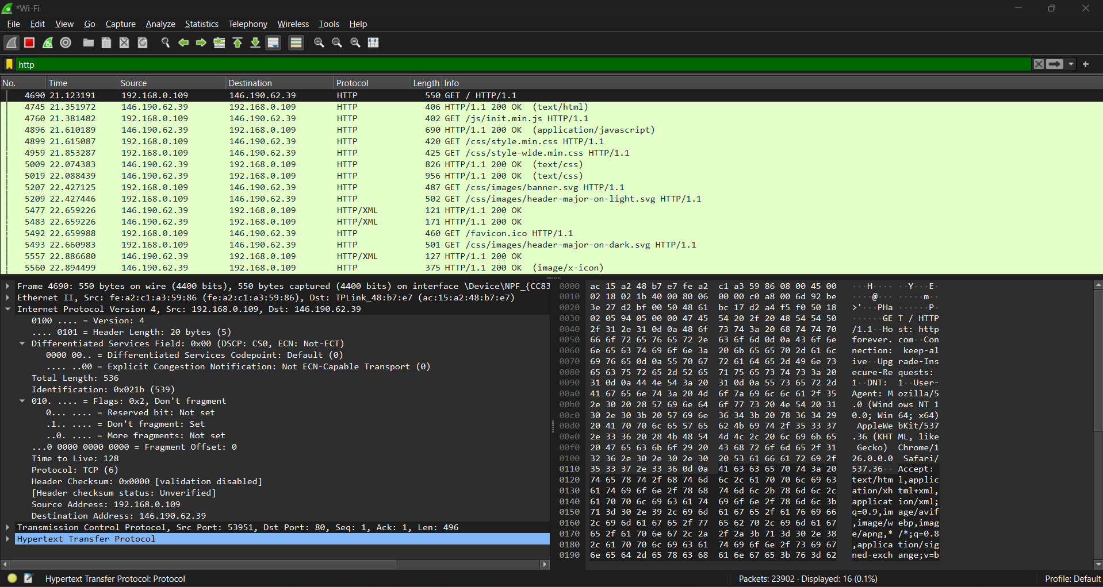

**Transfer Layer Protocol**: Providing reliable, ordered, and error-checked delivery of data. Here it is TCP.

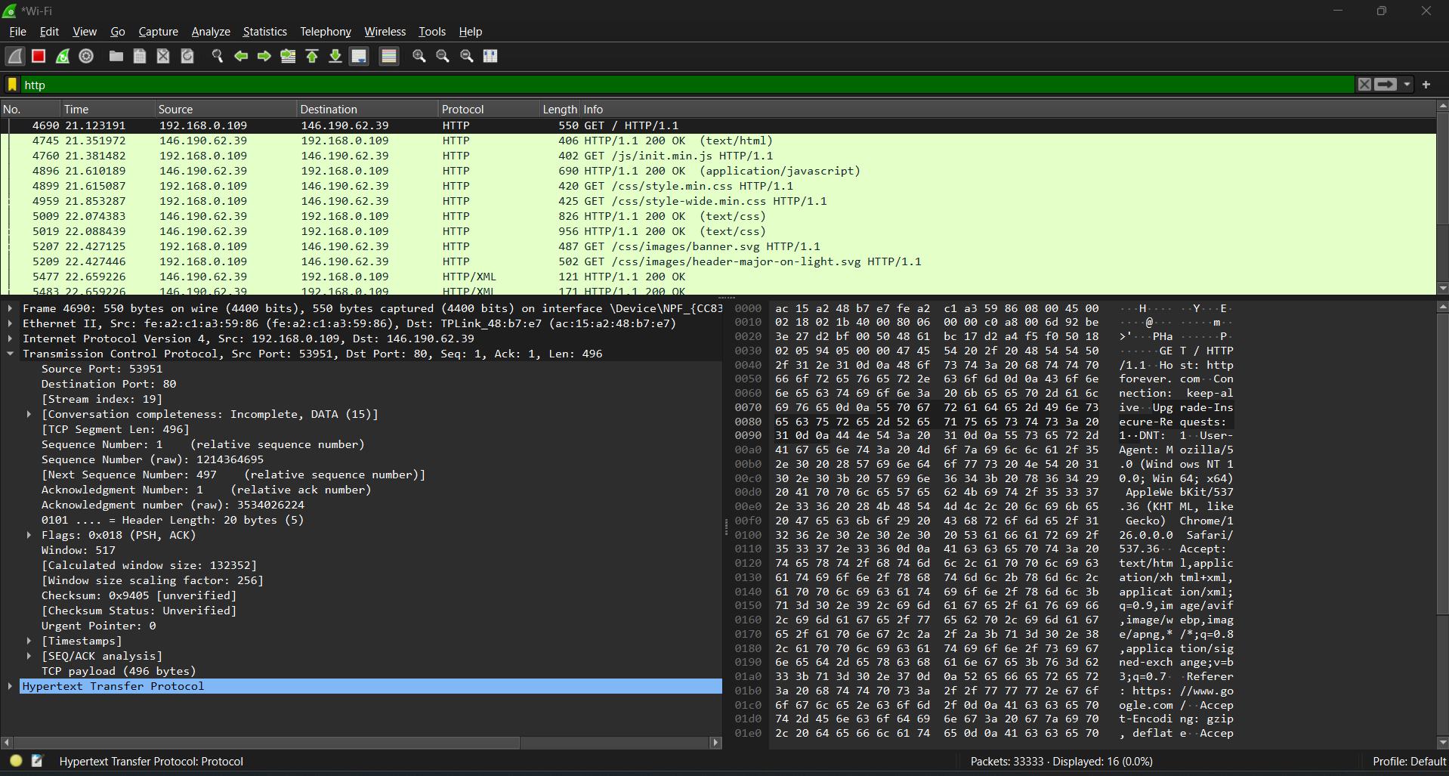

**Application Layer Protocol:** Used for transmitting web pages and other data over the internet. Here it is HTTP.